ASTRONOMY 206.2 GENERAL ASTRONOMY II

“Solutions” Sheet Student Name

Laboratory Exercise 15. Cepheids and the Distance Scale

Purpose. To use Cepheid variables to determine the distance to the Small Magellanic Cloud.

Procedure. See Laboratory Manual.

Equipment.

- Cepheid light curves and data

Data.

Cepheid log Period <M_{V}> Cepheid log Period <M_{V}>

SU Cas 0.29 –2.0 S Nor 0.99 –4.0
SZ Tau 0.65 –3.1 ζ Gem 1.01 –4.1
CV Mon 0.73 –3.4 X Cyg 1.21 –4.7
QZ Nor 0.74 –3.3 WZ Sgr 1.34 –5.1
V Cen 0.74 –3.4 SW Vel 1.37 –5.1
V367 Sct 0.80 –3.6 SV Vul 1.65 –6.1
DL Cas 0.90 –3.8

Harvard Variable Magnitudes m_{v} Period (days) log Period
Brightest Faintest Mean

2019 16.8 0.35
2035 16.7 0.44
844 16.3 0.49
2046 16.0 0.56
1809 16.1 0.60
1987 16.0 0.65
1825 15.6 0.79
1945 15.2 0.81
1903 15.6 0.88
2063
1873 14.7 1.11
843
1954 13.8 1.22
2060 14.3 1.24
847 13.8 1.44
1967
840 13.4 1.52
11182 13.6 1.60
837
1827 13.1 1.63
1877 13.1 1.70

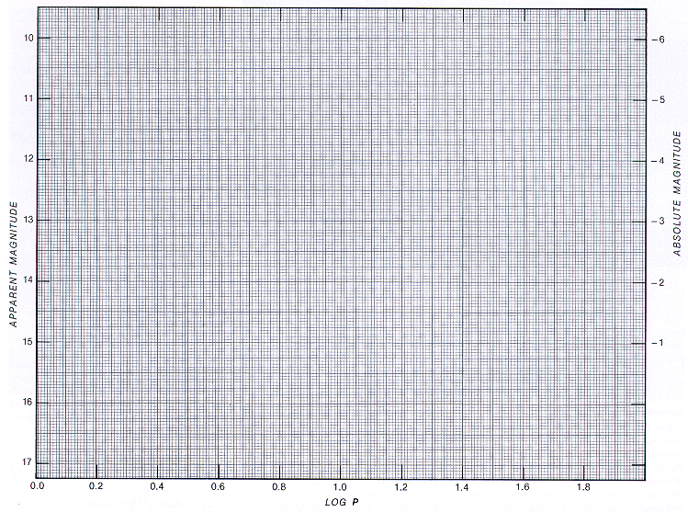

Apparent Magnitude of 10 day Cepheids (log P = 1.0) m_{v} =

Absolute Magnitude of 10 Day Cepheids (log P = 1.0) M_{V} =

Distance Modulus of Small Magellanic Cloud, m_{v} – M_{V} = –
=

Distance to Small Magellanic Cloud, d = 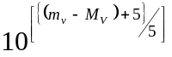
= 10
= 10
= parsecs

Discussion.

Conclusions.

